How Bonds Quietly Rule Everything: The Explainer I Wish We Had Sooner

I published a working paper on an economic model this summer and it got accepted on SSRN. Nothing fancy — just some equations and plots trying to make sense of interest rates and gold prices. But then I got ambitious.
“What if I add the yield curve?” I thought. That single question sent me down a rabbit hole that lasted over a month. Turns out, you can’t really understand yield curves without understanding bonds. And you can’t understand bonds without realizing that literally everything in finance somehow connects back to them.
Even my NPS account, which I barely think about, has this whole “bond allocation” section that suddenly made sense. My dad’s pension fund? Bonds. The reason crypto crashed when the Fed raised rates? Bonds. It felt like I’d been watching a movie with the sound off for years.

Why This Market Actually Matters
Here’s the thing that hit me first: most people obsess over stocks, but professionals watch bonds religiously.
The bond market is absolutely massive — bigger than the global equity market. We’re talking about a market that controls the cost of borrowing for everyone, shapes central bank policy decisions, and influences every asset from real estate to crypto.

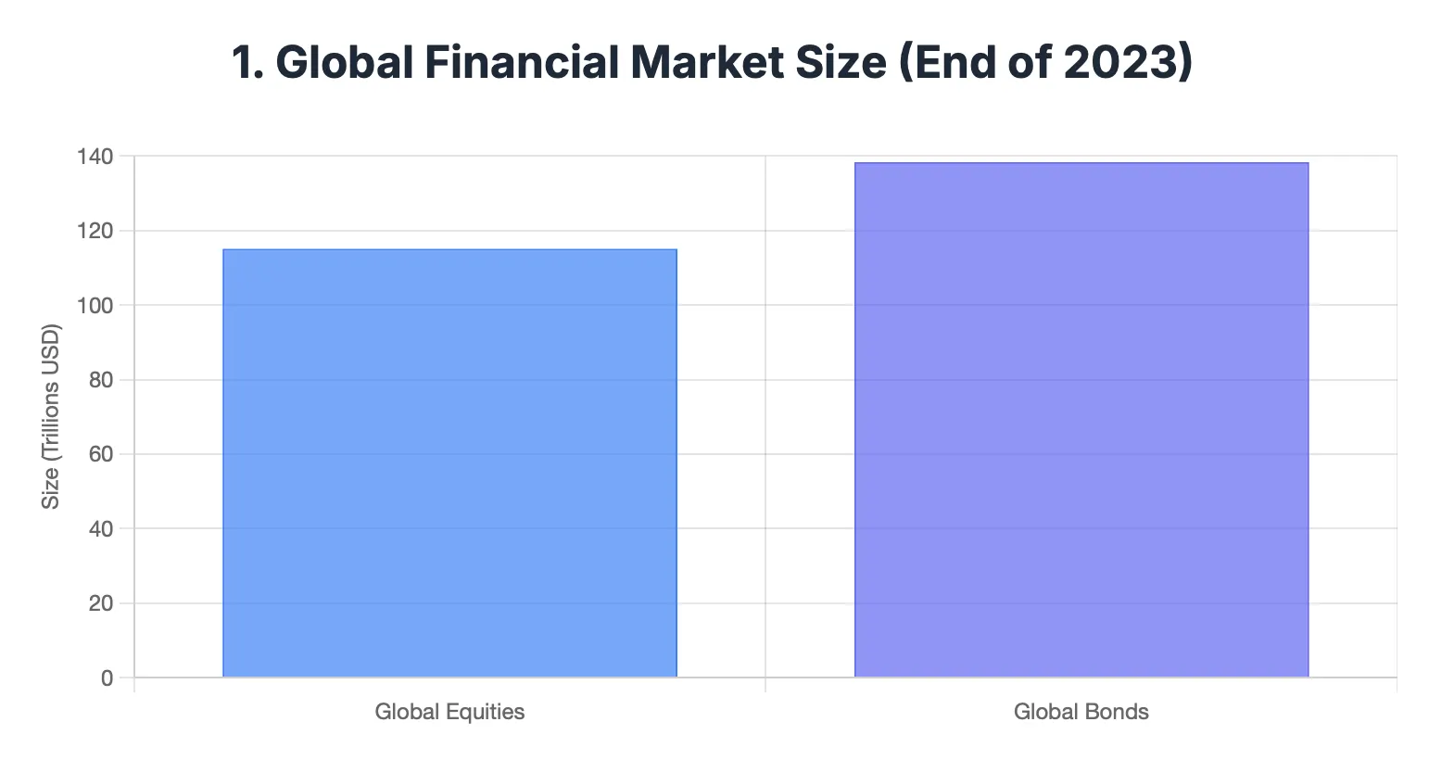

Yet somehow, retail traders, equity investors and students (myself included until recently) barely understand how it works. It’s like knowing how to drive but having no idea how the engine works.
The relationship between bonds and stocks isn’t just correlation — it’s causation. Bond yields literally determine the mathematical framework for stock valuations through discount rates.

The Fundamentals That Changed Everything

Bonds vs Stocks: The Core Difference
A bond is just a loan or IOU (I owe you) where you’re the lender. When you buy a government bond, you’re lending money to the government. When you buy a corporate bond, you’re lending to a company. They promise to pay you back the principal plus interest over time.
This is completely different from stocks, where one owns a piece of the company. With bonds, you get fixed returns (usually) instead of ownership stakes. Stocks give you upside potential but no guaranteed returns. Bonds give you contractual payments but limited upside.

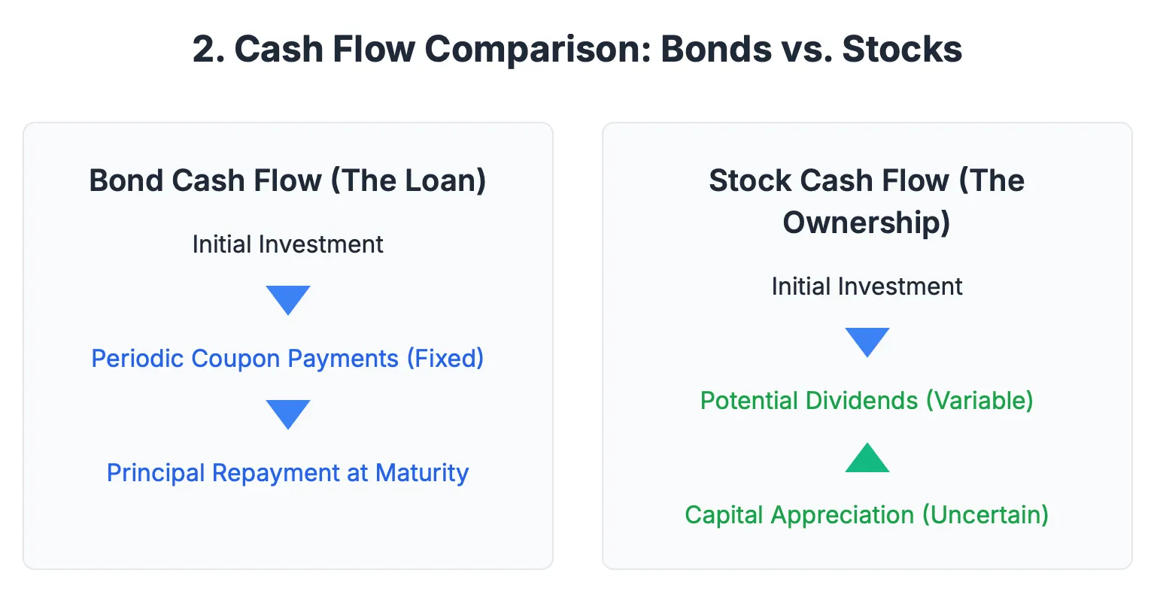

The cash flow is simple: you pay money upfront, get periodic interest payments (coupons), and get your principal back at maturity. With stocks, you might get dividends, but your returns come mainly from other investors willing to pay more for your shares.

The Vocabulary That Unlocks Everything
Bond jargon used to sound like a foreign language to me, but these terms are actually straightforward:
Face Value (Par): The amount you’ll get back when the bond matures (usually $1,000 or ₹1,000).
Coupon Rate: The interest rate the bond pays annually. A 5% coupon on a ₹1,000 bond pays ₹50 per year.
Current Yield: Annual coupon payment divided by current market price. This changes as bond prices move.
Yield to Maturity (YTM): The total return if you hold the bond until it matures, accounting for both coupon payments and any capital gain/loss.
Maturity Date: When you get your principal back.
Here’s the key insight that everything builds on: bond prices and yields move in opposite directions. When everyone wants to buy bonds (prices up), yields automatically fall. When people sell bonds (prices down), yields rise.

This inverse relationship explains so much market behavior once you see it. It’s also why bond markets and stock markets often move in opposite directions — when investors flee stocks for safety, they buy bonds, pushing bond prices up and yields down.
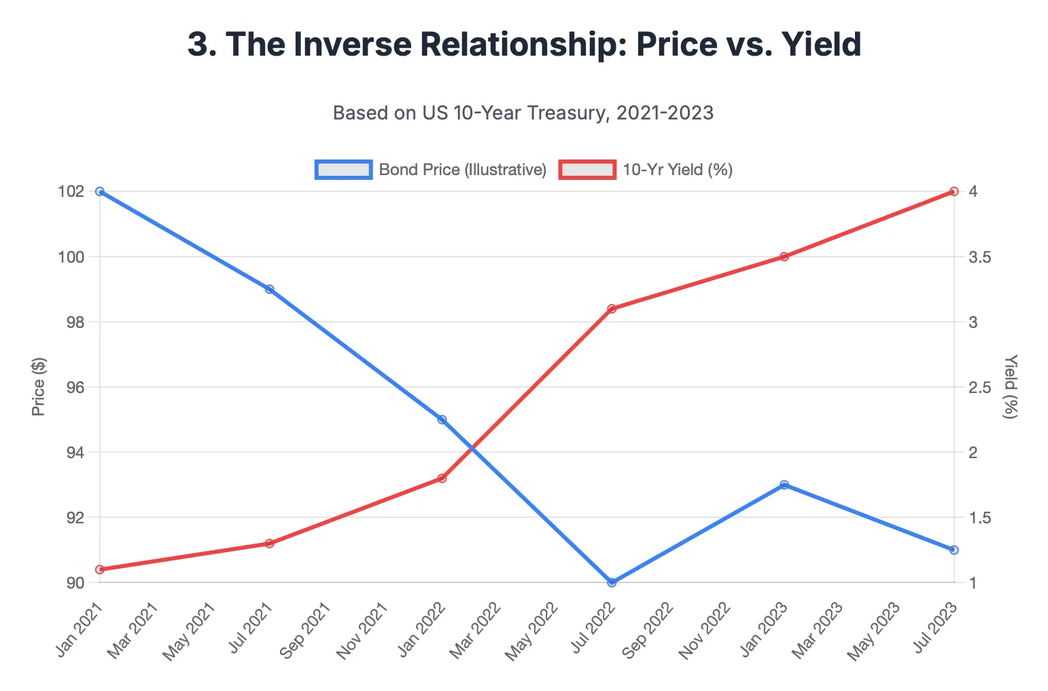

The Bond Universe
Bonds aren’t just one thing — there’s an entire spectrum:
Government Bonds: Issued by countries. Like US Treasuries, Indian G-Secs, German Bunds. Generally considered the safest.
Corporate Bonds: Companies borrowing money. Higher risk than government bonds, so they pay higher yields.
Municipal Bonds: Local governments and cities. In India, these are less common, but in the US they’re huge.
Sovereign Bonds: Foreign government bonds. When you buy US Treasuries as an Indian investor, you’re buying sovereign bonds.
Zero-Coupon Bonds: No periodic interest payments — you buy at a discount and get full face value at maturity.

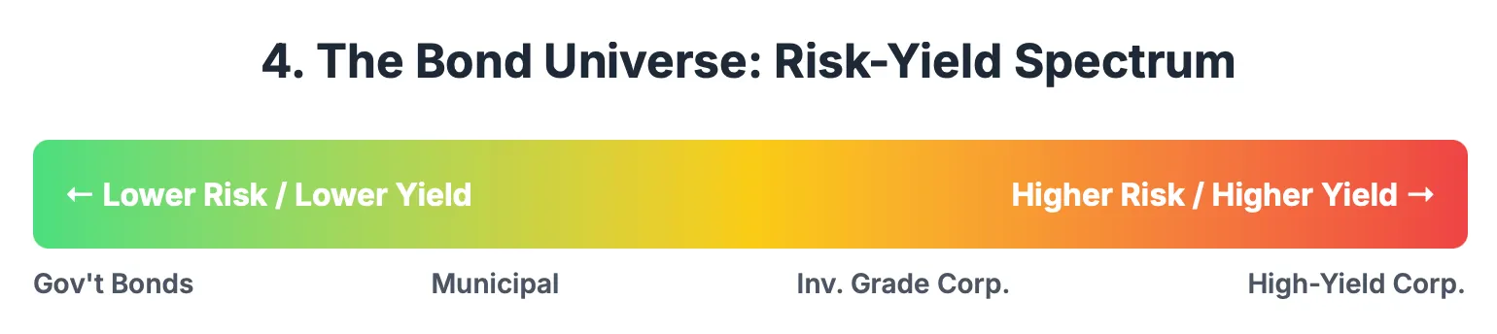

The risk-yield spectrum makes intuitive sense: safest bonds (like US Treasuries) offer lowest yields, riskiest corporate bonds offer highest yields. This creates a hierarchy that affects how investors move between asset classes.

How Bond Trading Actually Works
This was eye-opening for me. There are two markets:
Primary Market: When bonds are first issued through auctions. Governments and companies sell new bonds to raise money. Big institutional players like banks, pension funds, and insurance companies bid in these auctions.
Secondary Market: Where existing bonds trade, just like stocks. This is where price discovery happens and where most of the action is. The participants are massive: central banks, pension funds, insurance companies, foreign institutional investors, sovereign wealth funds. Retail investors are tiny players in this market.
Unlike stock markets where retail investors drive significant volume, bond markets are dominated by institutions managing trillions of dollars. This makes bond prices more stable day-to-day but creates huge moves when institutional sentiment shifts.

The Macro Layer That Blew My Mind

The Yield Curve: Economy’s Crystal Ball
This became my obsession. Plot government bond yields across different maturities — 2 year, 5 year, 10 year, 30 year — and you get a curve that reveals what smart money thinks about the economy’s future.
A yield curve is a line that plots the yields or interest rates of bonds that have equal credit quality but different maturity dates.
Normal Curve: Longer-term rates higher than short-term rates. This suggests healthy economic growth expectations. Makes sense, you want more compensation for lending money for longer periods.
Flat Curve: Short and long-term rates roughly equal. Usually signals uncertainty about economic direction.
Inverted Curve: Short-term rates higher than long-term rates. This is the famous recession predictor. It suggests people expect central banks to cut rates in the future due to economic weakness.

The crazy part? Yield curve inversions have preceded almost every major recession in the past 50 years. Stock markets usually peak around the time yield curves invert, then enter bear markets as the recession materializes.
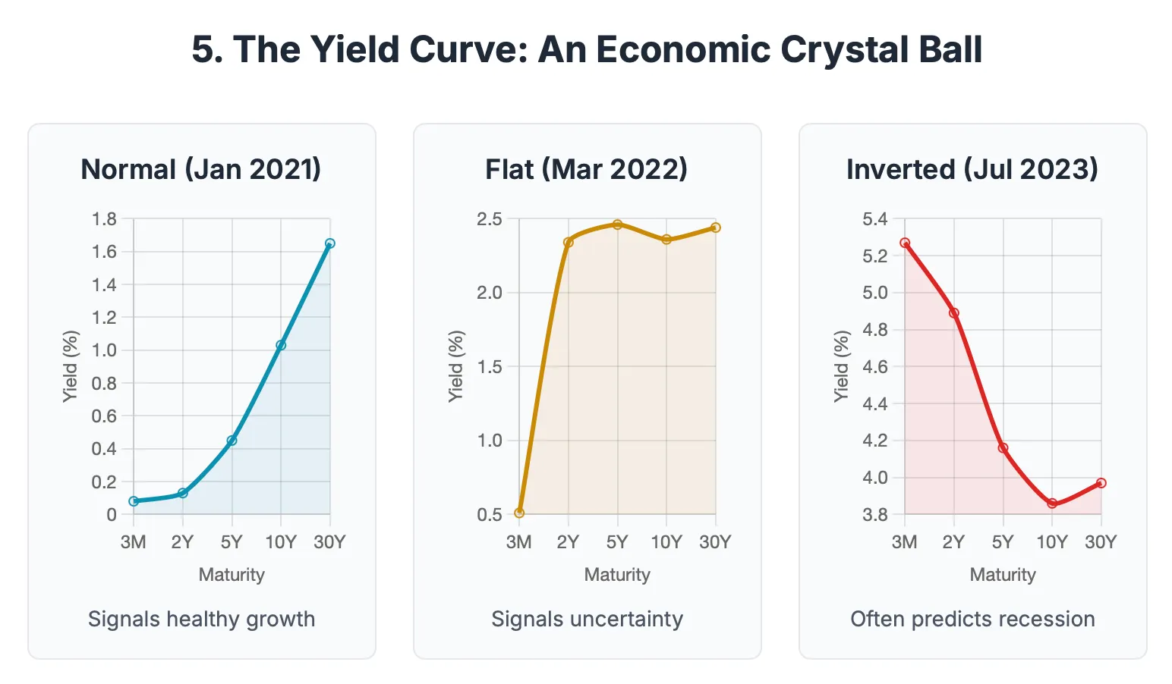

This is why bond traders are essentially economic forecasters. Their collective actions in buying and selling bonds across different maturities create this predictive curve.

Inflation, Interest Rates, and Bond Mathematics
Here’s where my economics understanding finally clicked with real markets. Inflation erodes the purchasing power of future cash flows. If you’re getting ₹50 per year from a bond, but inflation is 6%, your real return is negative.
Central banks respond to inflation by adjusting interest rates. When they raise rates, newly issued bonds offer higher yields, making existing bonds with lower coupons less attractive.
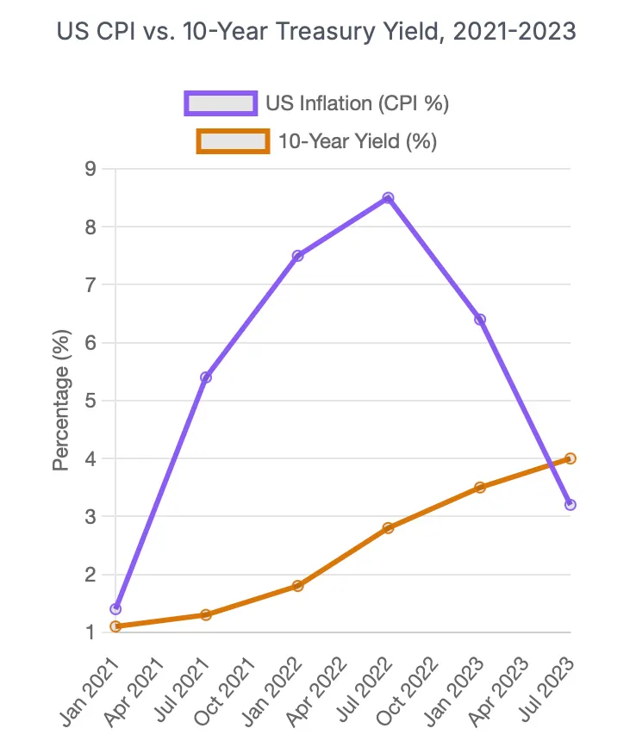

This is why bond prices fall when inflation expectations rise — investors demand higher yields to compensate for reduced purchasing power. And when bond yields rise, stock valuations get compressed because higher inflation makes future earnings worth less today.
The distinction between nominal yields (what you see quoted) and real yields (after adjusting for inflation) becomes crucial for actual investment decisions. Real yields are what actually matter for cross-asset allocation decisions.

Central Bank Policy Transmission
This was the missing piece in my economic model research. Central banks don’t directly control all interest rates — they control short-term rates and influence longer-term rates through bond market operations.
Open Market Operations: Central banks buy and sell government bonds to inject or remove money from the banking system.
Quantitative Easing (QE): Central banks buy massive amounts of bonds to push down long-term interest rates when short-term rates are already near zero.
Quantitative Tightening (QT): The reverse — central banks sell bonds or let them mature without replacement, pushing yields higher.
Repo and Reverse Repo: Short-term lending operations that influence overnight rates.
The transmission mechanism runs through bond markets. When the RBI changes the repo rate, it ripples through the entire yield curve via bond trading. Stock markets react immediately because investors recalibrate all asset valuations based on the new risk-free rate structure.

Fiscal Policy and Government Debt
Here’s something I never connected before: when governments run large fiscal deficits, they need to issue more bonds to fund the shortfall.
Higher bond supply (all else equal) means higher yields — the government needs to offer better rates to attract buyers for all that extra debt. This creates a direct link between fiscal policy decisions and interest rates across the economy. High debt-to-GDP ratios often correlate with higher government bond yields because investors worry about repayment ability.
Stock markets hate this dynamic because higher government bond yields create competition for equity investments and signal potential fiscal instability.

Global Capital Flows
The bond market is truly global. Foreign institutional investors chase higher yields across countries. When Indian government bonds offer attractive yields relative to US Treasuries (after accounting for currency risk), foreign money flows in.
The US 10-year Treasury yield acts as the global risk-free rate: the baseline against which all other investments are measured. When US yields rise, capital flows back to America from emerging markets, crushing both local bond and stock markets.
This is why RBI policy decisions aren’t made in isolation — they have to consider global yield differentials and capital flow implications. Indian stock markets often move more on US Treasury yield changes than on local company earnings.

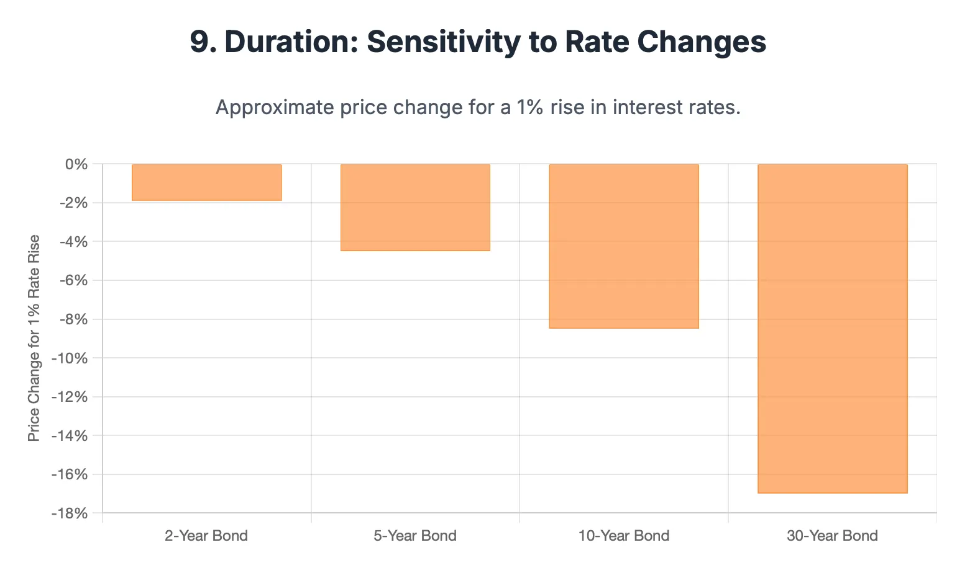

Bond Yields and Equity Valuations: The Fed Model
This is where finance theory meets market reality. The Fed Model compares stock earnings yields (earnings per share divided by stock price) to Treasury yields.
When Treasury yields are low, stocks can trade at high P/E ratios because the alternative (risk-free bonds) offers poor returns. When Treasury yields rise, stocks need to offer better value to compete.

Press enter or click to view image in full size
This explains why rising interest rates are kryptonite for high-multiple growth stocks — their valuations depend on low discount rates to justify sky-high prices. Value stocks with steady dividends actually become more attractive as their dividend yields compete better with bond yields.
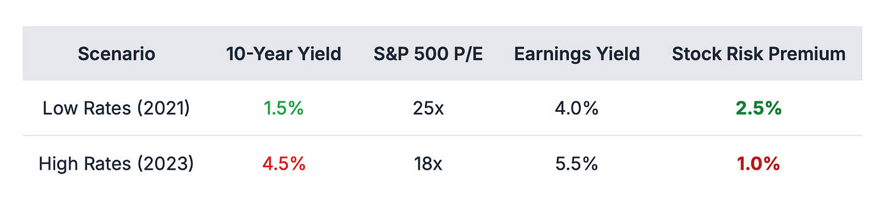

The relationship isn’t mechanical, but over long periods, stock market P/E ratios and bond yields show strong inverse correlation. Bond yields essentially set the hurdle rate for equity investments.

Bond-Stock Correlations: When They Move Together vs. Apart
Here’s what fascinated me most: sometimes bonds and stocks move in the same direction, sometimes opposite directions. The key is understanding why.
When they move opposite (flight to quality): Economic uncertainty makes investors sell stocks and buy bonds. Stock prices fall, bond prices rise, yields fall. This is the classic “risk-off” environment.
When they move together (inflation fears): Rising inflation expectations hurt both asset classes. Stocks fall because higher rates compress valuations. Bonds fall because investors demand higher yields to compensate for inflation. Both assets decline simultaneously.
When they move together (growth optimism): Strong economic growth can lift both stocks (higher earnings expectations) and bond yields (higher growth means higher rates). Stocks rise, bonds fall, yields rise.
Understanding which regime you’re in determines whether bonds are diversifying your stock exposure or amplifying your risk.

The Indian Context: Where Bonds Meet Stocks
Researching Indian government securities (G-Secs) made this personal. The India 10-year government bond yield directly affects Nifty valuations through the discount rate mechanism.
Every RBI monetary policy committee meeting, every inflation print, every fiscal deficit announcement moves the Indian yield curve. And those movements ripple through equity markets, currency markets, and foreign investment flows.

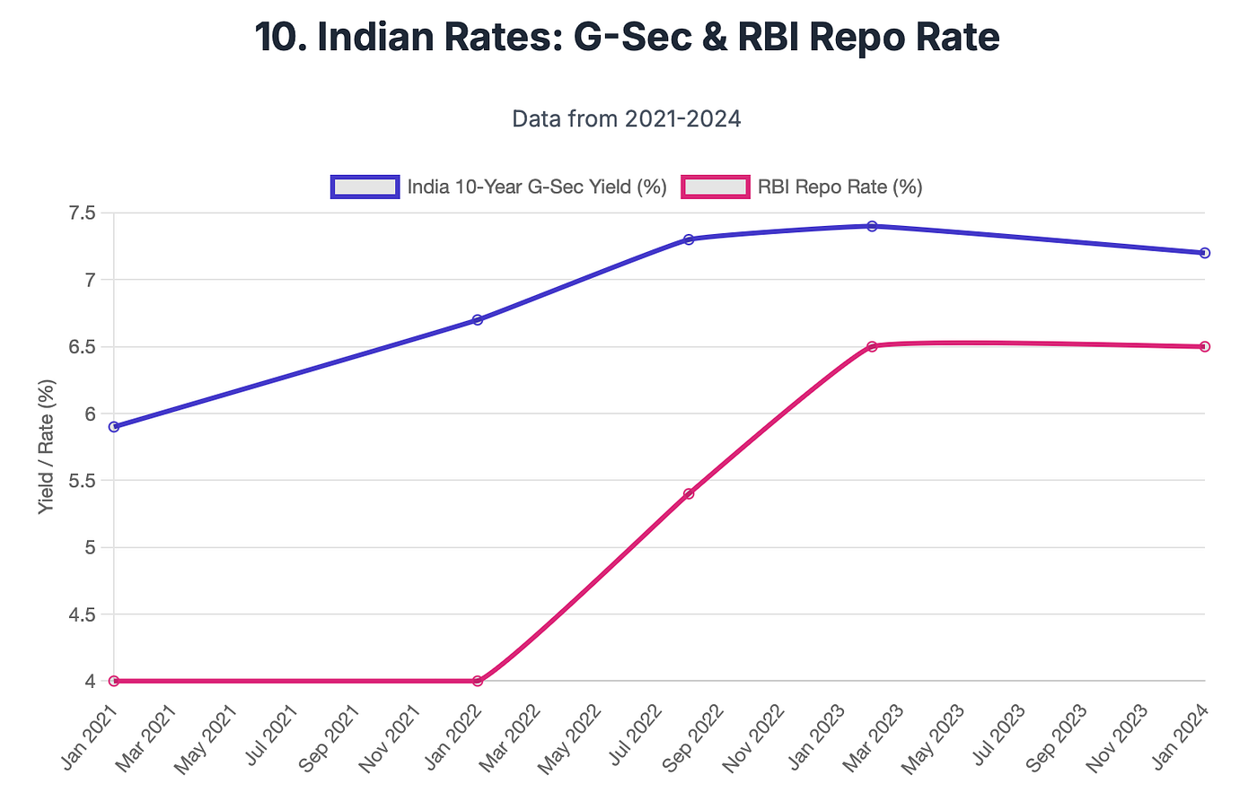

Press enter or cli

ck to view image in full size
RBI Governor speeches are closely watched by both bond and equity traders for policy signals. Even subtle changes in language about inflation targeting or growth concerns can move yields significantly, which immediately affects stock valuations.
The correlation between Indian 10-year yields and Nifty P/E ratios is striking. When yields rise above certain thresholds, foreign investors start rotating from Indian stocks to bonds, creating selling pressure in equity markets.
Indian investors can access this dynamic through:
- Direct G-Sec investments via NSE/BSE
- Bharat Bond ETFs for corporate bonds
- Debt mutual funds that invest in government and corporate bonds
- Balanced funds that actively manage stock-bond allocation based on yield levels
Even our NPS accounts have significant bond allocations that get affected by these yield movements, creating a natural hedge when stock markets fall due to rising rates.

Why This All Clicked During My Research
When I was working on my economic model, I kept seeing how interest rates affected gold prices but couldn’t figure out the exact transmission mechanism.
Turns out, it runs through bonds and opportunity cost, but it also explains stock market behavior.
When central banks raise rates, newly issued government bonds offer higher risk-free yields. This makes gold (which pays no interest) less attractive, but it also makes stocks less attractive unless they can grow earnings fast enough to justify higher discount rates.
The mechanism affects everything:
- Corporate borrowing costs (through corporate bond yields affecting business investment)
- Housing demand (through mortgage rates tied to bond yields affecting consumer spending)
- Currency values (through interest rate differentials affecting foreign investment)
- Stock valuations (through discount rate effects on present value calculations)
Stock markets often decline before recessions not because earnings have fallen yet, but because bond markets are already pricing in the economic weakness through higher credit spreads and inverted yield curves.

The Correlation Patterns That Matter
After studying this for weeks, I identified key correlation patterns between bonds and stocks:
During Normal Times: Bonds and stocks often move in opposite directions. When economic data is mixed, investors rotate between risk assets (stocks) and safe assets (bonds) based on the news flow.
During Crises: Flight to quality dominates. Stocks fall hard, government bonds rally strongly, yields plummet. Corporate bonds get hit almost as badly as stocks due to credit risk concerns.
During Inflation Scares: Both bonds and stocks fall together. Bonds fall because investors demand higher yields. Stocks fall because higher discount rates crush valuations, especially for growth companies.
During Deflationary Periods: Both can rally together. Bonds rally because yields fall to extremely low levels. Stocks can rally because companies benefit from lower input costs and borrowing costs, even as growth slows.
The key insight: the correlation between bonds and stocks isn’t fixed — it depends on what’s driving market movements. Understanding the underlying economic regime helps predict whether bonds will diversify or amplify your stock market risk.

The Bigger Picture: Bonds as the Financial System’s Operating System
After weeks of research, I finally understood why that finance professor said, “If you want to understand markets, start with stocks. If you want to understand economies, start with bonds.”
Stock prices reflect sentiment, growth stories, and individual company performance. Bond prices reflect mathematical reality about interest rates, inflation expectations, and macroeconomic fundamentals that affect ALL stocks.

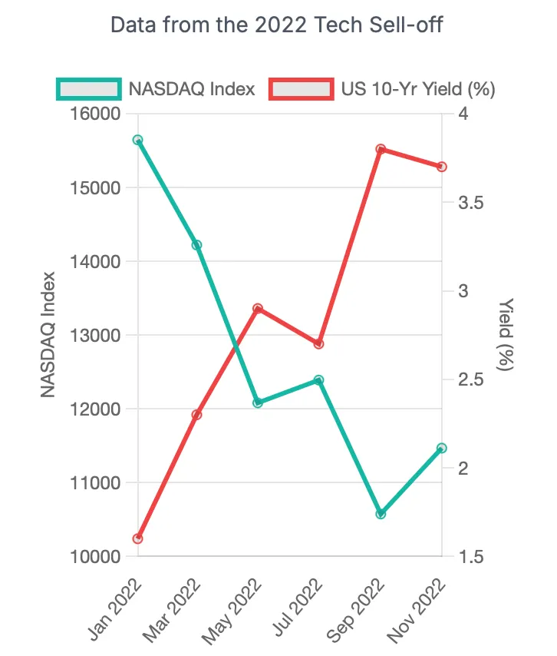

Bonds literally set the discount rates used in every stock valuation model. When bond yields change, every stock’s fair value changes mathematically, regardless of company-specific factors.
This is why macro hedge funds often make their biggest bets in bond markets but profit from the resulting moves in stock markets. They’re not predicting which stocks will outperform — they’re predicting how changing interest rates will affect all stock valuations.
The correlation isn’t just statistical — it’s mathematical. Bond yields feed directly into the weighted average cost of capital (WACC) calculations that determine how much companies’ future cash flows are worth today.

The Personal Investment Revolution
The weirdest part about this journey? Once you understand bonds, your entire investment perspective changes, especially regarding stock investments.
Those SIP investments I make monthly? The equity funds perform better when bond yields are stable or falling (lower discount rates boost stock valuations). The debt funds I ignored? They’re actually sophisticated bond portfolios that can generate solid returns and provide genuine diversification when stocks fall due to non-inflation-related factors.
My NPS allocation between equity and debt? Now I understand it’s really an allocation between growth assets (sensitive to bond yields) and bond-like assets (that move inverse to interest rates). The optimal allocation depends on the interest rate cycle and correlation regime.
Even my stock selection strategy evolved. I started paying attention to companies’ debt levels and interest coverage ratios, because rising bond yields hurt leveraged companies disproportionately. High-dividend stocks became more interesting as their yields compete directly with bond yields.

The takeaway that keeps hitting me
I spent years thinking finance was about picking winning stocks and timing markets. Turns out, it’s mostly about understanding how money flows between different assets based on changing risk-free rates determined in bond markets.
Stock picking might get you 2–3% of extra returns if you’re exceptionally skilled. But understanding bond-stock correlations and interest rate cycles can help you avoid 20–30% drawdowns by recognizing regime changes before they fully play out in equity markets.
The bond market isn’t sexy. It doesn’t have memes or Reddit communities. But it’s the financial system’s operating system; the fundamental layer that determines the cost of capital for everyone and everything, including every stock you’ll ever own.
Stock markets are like apps running on top of this operating system. Real estate, commodities, currencies, crypto are all apps. But the OS that runs it all? That’s the bond market setting risk-free rates, credit spreads, and the mathematical framework for valuing every other asset.
Understanding this doesn’t just make you a better bond investor. It makes you a better stock investor because you finally understand the invisible forces that drive 70% of equity market movements. And honestly? That feels like a genuine superpower in a world where most people think stock analysis begins and ends with PE ratios and earnings growth. The bond market matters because it’s where the future gets priced, one yield curve at a time. And every stock valuation depends on getting that future right.

